**THE RIGHT TRACK**

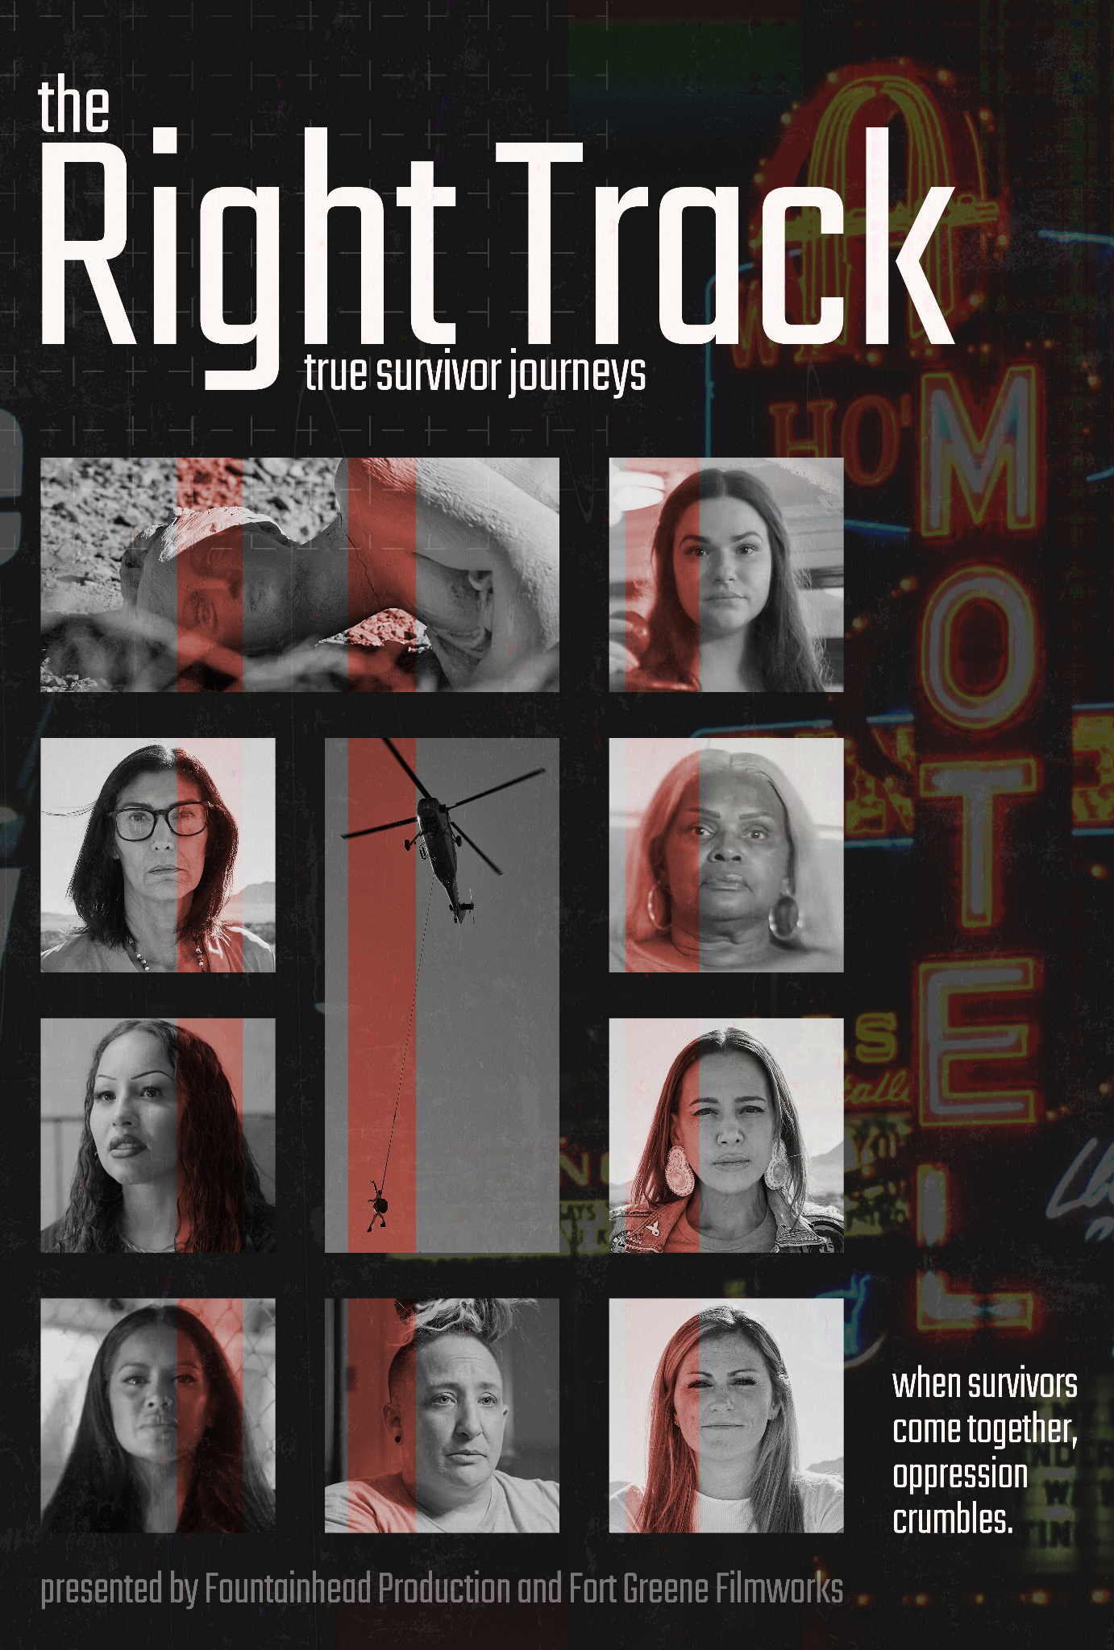

***The Right Track*** *is a powerful documentary that amplifies the voices of survivors of sex trafficking, revealing their resilience, heartbreak, and courage as they fight for freedom, justice, and a future where exploited individuals are no longer criminalized but protected.*



**DC/DOX Festival Screening:**

Friday, June 13, 2025 3:30 PM EST

Regal Gallery Place

**IMAGES:** [HERE](https://drive.google.com/drive/folders/1tTaff6psainVGbxr-Dw68jibRf33gIqa?usp=sharing) *(Courtesy of THE RIGHT TRACK)*

Director: Shareen Anderson

In Association with: Fountainhead Production, Fort Greene Filmworks

Director of Photography: Andrew Dunn

Executive Producer: Lisa Kraus Edwards

Post-Production Supervisor: Sean E. Stall

Run Time: 92 Minutes

**WEBSITE:** [www.righttrackfilm.com](https://righttrackfilm.com)

**Instagram:** [@righttrackfilm](https://www.instagram.com/righttrackfilm/) **/ YouTube:** [righttrackfilm](https://www.youtube.com/@righttrackfilm)

**MEDIA CONTACT:** The Right Track / [press@righttrackfilm.com](mailto:press@righttrackfilm.com)

**LOGLINE:**

***The Right Track*** is a powerful documentary that amplifies the voices of survivors of sex trafficking, revealing their resilience, heartbreak, and courage as they fight for freedom, justice, and a future where exploited individuals are no longer criminalized but protected.

**SYNOPSIS:**

***The Right Track*** is a gripping documentary that shines light on the relentless fight to end sex trafficking and sexual exploitation across North America. At its core is the movement to bring awareness to and drive legislative support for the Survivor Model at the state and federal level—a transformative approach that decriminalizes prostituted individuals while maintaining strict penalties for pimps, traffickers, and sex buyers who drive the commercial sex industry. Through powerful narratives from survivors, advocates, policymakers, and law enforcement, the film delves into the heart of the crisis, revealing the courage that survivors require to escape “the life” and rebuild, either off the track or out of the brothel system. It explores what’s needed to bring traffickers and buyers to justice and how trafficking thrives not just in far flung places, but right in our own neighborhoods. The Right Track is both a call to action and a testament to the resilience of survivors fighting for change.

*Warning: This film contains violent content and stories of intense sexual trauma. If you suspect you are a victim of sex trafficking, call the National Human Trafficking Hotline at 1-888-373-7888 or text “help” to 233722.*

**DIRECTOR’S STATEMENT:**

When I began working on *The Right Track*, I carried many of the assumptions that are common in our society. I believed that most people involved in prostitution were there by choice—and that legalizing sex work would create safer conditions, reduce stigma, and curb trafficking. I supported the idea that people should have autonomy over their bodies and how they make a living.

But as I listened to survivors and spent time with people directly impacted by the commercial sex trade, my perspective changed. I came to understand that what we often label as “choice” is more accurately a lack of alternatives—shaped by poverty, trauma, coercion, and systemic inequality. Survivors shared harrowing stories of exploitation, not just in illicit environments, but within legalized systems that were supposed to offer safety. Many described profound trauma and the lasting effects of being treated as commodities.

*The Right Track* is a product of that awakening. It is a film grounded in listening—especially to the voices of those who have lived through exploitation and are now leading the fight to end it. I hope this film encourages viewers to examine their own assumptions, to recognize the blurred lines between prostitution and trafficking, and to consider what real justice and protection look like for survivors. Most of all, I hope it contributes to a growing movement that centers truth, dignity, and accountability.

**ABOUT THE DIRECTOR:**

**Shareen Anderson** is an award-winning producer, director, and showrunner based in New York City. She has developed and produced a wide range of documentary films and series for major networks including A&E, PBS, Netflix, CNN, Al Jazeera English, Food Network, Travel Channel, Channel 4 UK, Oxygen, Lifetime, National Geographic, and Discovery.

She created and executive produced *The Murder of Laci Peterson*, a six-part series for A&E that won a silver medal at the New York Festivals International Television and Film Awards. Her eight-part series *Saving Soweto* for Al Jazeera English earned a bronze medal at the same festival. *Return To The USS Atlanta*, which she directed and produced, won a Spirit of Independents Award at the Fort Lauderdale International Film Festival and aired on Netflix and PBS. Her debut feature, *Charents: In Search of My Armenian Poet*, won the Audience Choice Award at the Pomegranate Film Festival in Toronto.

Other notable projects include *A Different Country* (ETV South Africa), *Forgotten Freedom Fighters* (Al Jazeera English), and *These Streets Belong To Us*, which aired on MNet Africa and screened internationally. As a freelance supervising producer, her recent credits include *To Catch A Smuggler* (National Geographic), *The Shadows of Death*, and *Suspicious Minds* (Investigation Discovery).

She co-founded the Jozi Film Festival in Johannesburg in 2011 and has directed the Mystic Film Festival in Connecticut since founding it in 2017. Anderson holds an M.A. in Russian Language and Literature from St. Petersburg State University and a B.A. in French and Russian from Washington State University.

**ABOUT Fountainhead Production:**

Fountainhead Production offers an unmatched combination of Emmy- and ACE-Award winners, outstanding experience and care for detail, true state-of-the-art equipment, diligent work ethic, and a proven record of delivering television production at efficient cost to the client. Our principals have more than a quarter century of network experience in production, writing, and on-the-air delivery at industry leaders including ABC, CBS, ESPN, Turner, Lifetime, and networks worldwide.

**ABOUT Fort Greene Filmworks:**

Fort Greene Filmworks is an award-winning film and video production company dedicated to powerful storytelling, building awareness, and making an impact. Based in New York City, we create and produce compelling films and series for streaming, broadcast, and theatrical distribution.